**Heat Map**

A **heat map** (or **heatmap**) is a data visualization technique that shows magnitude of a phenomenon as color in two dimensions

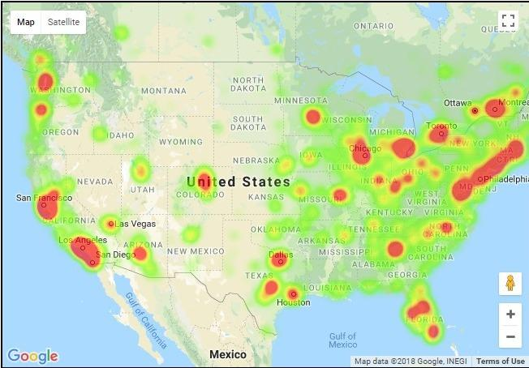

**Mumbai map for reference**

Link : <http://stopcoronavirus.mcgm.gov.in/insights-on-map>

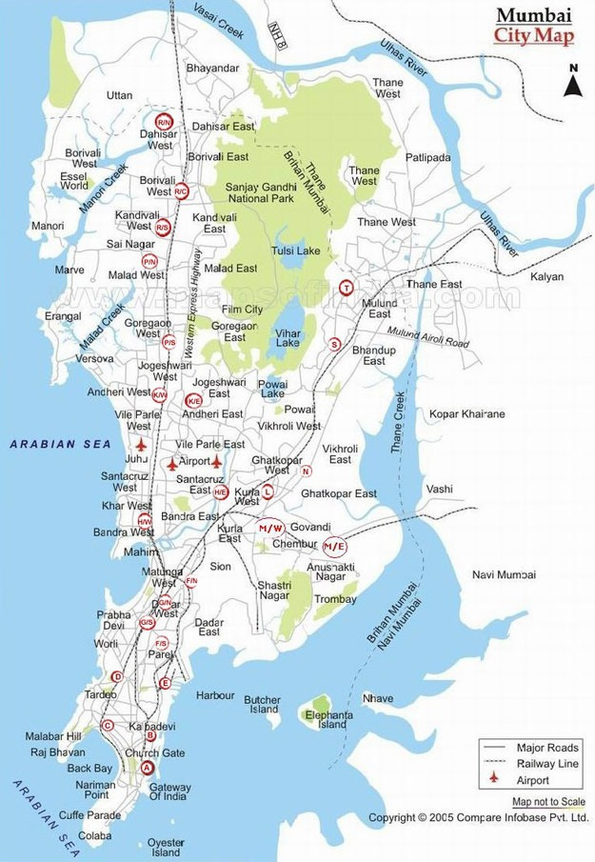

**File - input_file_v1_dashboard.csv**

Country : Self Explanatory

State : Self Explanatory

City : Self Explanatory

Ward location : Name of the ward location

Ward : Ward Number

Population : Population in that ward

Density per square kilometer : Number of people per square kilometer

Senior citizen % : percentage of senior citizen

Area : Area in square kilometer

Educational institutes : Number of Educational institutes in this ward area

Hospitals : Number of hospitals in this ward area

Supermarts/malls : Number of supermarts/malls in this ward area

Critical congestion points : Number of critical congestion points

Commercial complexes : Number of commercial complexes in this ward area

Residential areas : Number of residential areas

**File : Facilities_in_Mumbai_COVID_19_Cases.csv**

Ward : Ward Number

Number of Cases- Very Congested Area : Number of cases in very congested area of this ward

Number of Cases- Medium Congested : Number of cases in medium congested area of this ward

Number of Cases- Standalone Structure : Number of cases in standalone structure of this ward

Date Entered : Data entered is 11th April or Earlier